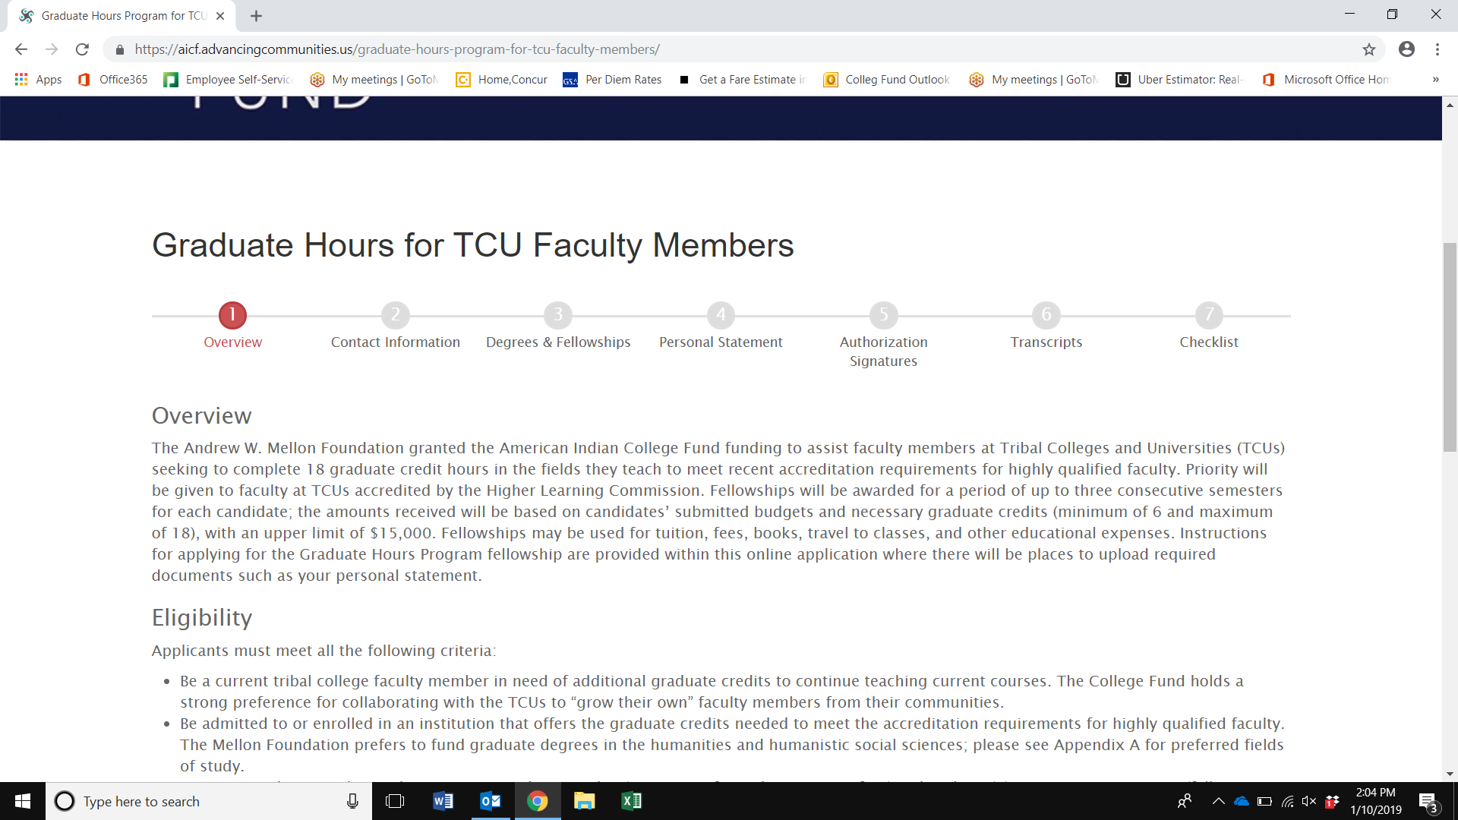
8. Checklist
De
7. Academic Plan and Detailed Budget

7. Academic Plan, Detailed Budget, & Supporting Documents

Please create fillable form for Academic Plan and Detailed Budget. See below and please use your expertise to format and create fields. Happy to chat and would like to review before changes are made. Thank you!
Add: button or box where applicants can add supporting document for tuition, fees, books, etc.
COURSE PLAN
 | Semster 1 | Semester 2 | Semster 3 | Credits
COURSES
 |  |  | TOTAL
DETAILED BUDGET
 | Semster 1 | Semester 2 | Semster 3 | Total
EXPENSES
Tuition
Fees
Books
Course Supplies
Course Equipment
Other:
Other:
 |  |  | TOTAL

